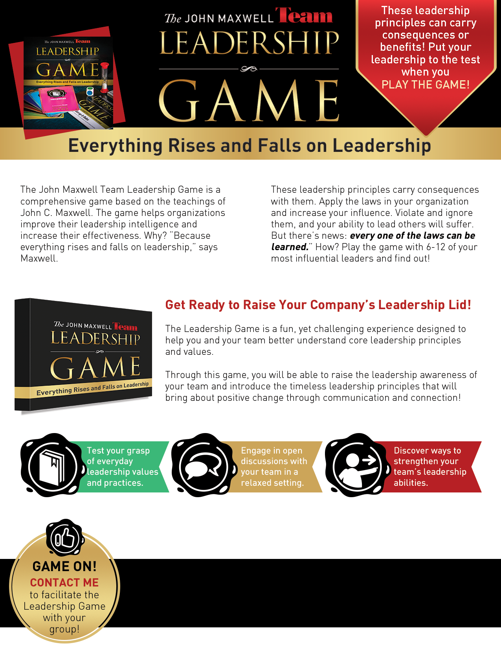

* 816-582-7276 (mobile)
* chad@chadearhart.com

Chad Earhart Co.

Certified Speaker, Trainer & Coach

with The John Maxwell Team